POD Teaching Session Number 5
How to Hear God’s Voice
Module C
Keys #2, #3 and #4
Learning Objectives:
- Key #2 How to quiet yourself so that you can hear God
- Key # 3 How to look for a vision as you pray
- Key # 4 Writing down the flow of thoughts and pictures that come to you
- Key #2 How to quiet yourself so that you can hear God

This portion of the Intensive has been designed to help you understand the way to quiet yourself before the Lord so that you can discern His Voice, turning your full “spiritual” attention to the Lord thereby being able to follow the Lord’s leading in your life and then living out Romans 12:2 which states “Then you will be able to test and approve what God’s will is (for your life and purposes), his good, pleasing and perfect will”.
In order for us to hear the still, small voice of God within us as spontaneous thoughts and pictures, we must still ourselves before him. (Ps. 46:10). This act is the doorway for being in the right position to hear God’s voice. In Psalm 62:1, 5 David commanded his soul to wait in silence for God only and in Psalm 37:7 David commands his soul to “wait patiently for Him”
So often, we miss the importance of quieting ourselves before the Lord in ___________________ to hear His voice. Our lives are so compacted and compartmentalized that we relegate God to a small portion of time each day and instead focus on the “tyranny of the urgent” that each day presents only to find out that we gave God our “last fruits” instead of our “first fruits”. What happened to the idea that technology would solve all of our time constraints as was promised in the last generation?
In order for our inner man to commune with God, we must first remove external distractions. We must find a ___________________ where we can be alone and undisturbed, so that we can center our hearts without being distracted by all that calls out to our souls both externally and internally.
Key Practice:
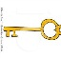
Set apart a specific time and place for you to enter into prayer time and personal conversation with God. Ask God to protect each planned divine meeting with him and come prepared to hear from God! 2 Sam. 5:17 tells us the story that when the Philistines heard that David had been anointed King over Israel, they went up in full force to search for him, but David heard about it and went down to the strongholds. Likewise, understand that you have been anointed to do God’s will and the enemy, like the Philistines will pursue you to distract you from hearing God voice, GO TO YOUR STRONGHOLDS!
The best time of day and place for me to meet the Lord in stillness and simplicity is:
____________________________________________________________

Secondly, we must ___________ to quiet our inner being – all those voices and thoughts within us that are competing for our attention. Until the competing voices are quieted, we will never get to a point when we clearly hear God’s voice.
There are many ways we can quiet our inner being before God and hear his voice. The chart below reveals effective ways of quieting yourself in preparation to hear God’s voice:

REMOVING INNER NOISE
(Voices, Thoughts, Pressures)
Problem | Solution
Thoughts of things to do | Write them down so that you do not forget and address them later.
Thoughts of sin consciousness | Confess your sins and clothe yourself with the robe of righteousness before God (1 John 1:9).
Mind unsettled in general | Focus on Jesus himself and concentrate on Him, the goal and object of our faith (Hebrews 12:2).
Need to get in touch with your heart | Begin singing and listening to the spontaneous song bubbling up from your heart.
Need additional time to commune when your mind is poised and still | Realize that times when you are doing automatic activities (e.g. driving, bathing, exercising, routine jobs etc.) are ideal times to hear from God His thoughts and pictures.
You may want to spend more time asking God to show you if there are other unrevealed patterns or voices that keep you from stilling yourself before the Lord. Fill in the problems below and ask God for His solution so that you can hear His voice more clearly and consistently. You can do this by asking God to show you what is in your _____ at the moment of contact with His Spirit. God will show you what the object or issue is. Write it down here so that you can listen to the Lord and examine it from His point of view. Also discuss with you POD group later what God revealed to you and what you collectively think is the best solution.
Problem | Solution
IDENTIFYING THE STATE OF BEING STILL:
Being still before the Lord in a contemplative or meditative state involves properly positioning ourselves before the Lord with our whole heart. This involves the five aspects as listed below.
- Physical Calm:
The Biblical exhortation concerning physical calm:
Hebrews 4:9-11 states “There remains therefore a Sabbath rest for the people of God. For the one who has entered into His rest has himself also rested from his works, as God did from his. Let us therefore be ________ to enter into that rest, lest anyone fall through following the same example of disobedience”
The opposite of physical calm is physical tension. Is this your struggle today?
- Focused Attention:
The Biblical exhortation concerning focused attention
Hebrews 12:1-2 states “…and let us…lay aside every encumbrance, and …sin which so easily entangles us, and let us run…_____________ on Jesus, the
author and perfecter of our faith….”.
John 5:19 states “Truly, truly, I say to you, the Son can do nothing of Himself, unless it is something He _______ the Father doing; for whatever the Father does, these things the Son also does in like manner”.
The opposite of focused attention is distraction. Is this your struggle today?
- Letting Be:
The Biblical exhortation concerning letting be:
Psalm 46:10 states “Cease __________ (aka “Be still”) and know that I am God”

Phil. 4:6-7 states “Be anxious for nothing, but in everything, by prayer and supplication with thanksgiving, let your requests be made known to God. And the peace of God, which surpasses all comprehension, shall guard your _______________________ in Christ Jesus”.
The opposite of letting be is over-control. Is this your struggle today?
- Receptivity:
The Biblical exhortation concerning receptivity
John 15:4-5 states “Abide in Me, and I in you. As the branch cannot bear fruit of itself, unless it abides in the vine, so neither can you, unless you abide in Me. I am the _______ you are the _______________; he who abides in Me, and I in him, he bears much fruit; for apart from Me you can do nothing”.
James 4:10 states “Humble yourself before God and he will lift you up…”
The opposite of receptivity is activity. Is this your struggle today?
- Spontaneous Flow:
The Biblical exhortation concerning spontaneous flow:
John 7:38-39 states “He who __________ in Me, as the Scripture said, “From his innermost being shall flow rivers of living water.” But this He spoke of the Spirit, whom these who believed in Him were to receive…”
The opposite of spontaneous flow is analytical thoughts. Is this your struggle today?
Contrasting Biblical Meditation with Non-Christian Meditation
Christian meditation is a form of prayer and contemplation in which a structured attempt is made to get in touch with and to deliberately reflect upon the revelations of God. Christian meditation involves the process of deliberately focusing on specific thoughts (God’s thoughts) such as biblical passages (Logos) and pictures and reflecting on their meaning in the context of God’s love for us.
Psalm 1 is a great example of the life lived out of meditation and it states “His delight is in the law of the Lord, and in his law doth he ________ day and night”. KJV
Psalm 19:14 states “Let the words of my mouth and the meditations of my heart be acceptable in thy sight, Oh Lord, my strength and my Redeemer”. KJV
Christian Meditation is always grounded in the Bible; it is characterized by responding to God’s love for us and leads us to loving God more and deeper. Christian meditation always draws us towards God the Creator, not any aspect of his creation!

Non-Christian Meditation – The styles of meditation found in Buddhism and the New Age Movement strive to “disengage” your mind while Christian meditation aims to fill your minds with thoughts and scripture that the Holy Spirit brings (bubbles) up to your mind.
Another difference between Christian meditation and Non-Christian meditation is that Christian meditation puts our focus on the Creator versus non-Christian meditation focuses on creation. In preparation for this presentation I conducted an interview with a middle aged man that has practiced TM (transcendental meditation) for over 25 years. He explained that he always begins the process with emptying his mind and then an image is brought to his mind. It could be a squirrel, tree, forest or other object, but the one object that most often comes up is a candle. That is his favorite object to focus on during his trance. His motive is to disengage from his current environment and find a different spiritual reality.
Removing All Idols in Your Heart by fixing your Eyes on Jesus:
When we pray or speak to God we are fixing the eyes of our hearts either on Jesus or the object of our prayer that is not Jesus. We all have prayed for something and during our prayer time have focused on the object (creation) rather than the Creator.
The principle of defining what an idol is while you are praying is when any object of creation is larger than Jesus in the eyes of your heart, the object of creation can become an idol.
Ezekiel 14:4 states “…any man in the house of the Lord who sets up his idols in his heart, puts right before his face the stumbling block of his iniquity, and then comes to the prophet, I the Lord will be brought to give him an answer in the matter in view of the multitude of his idols.”
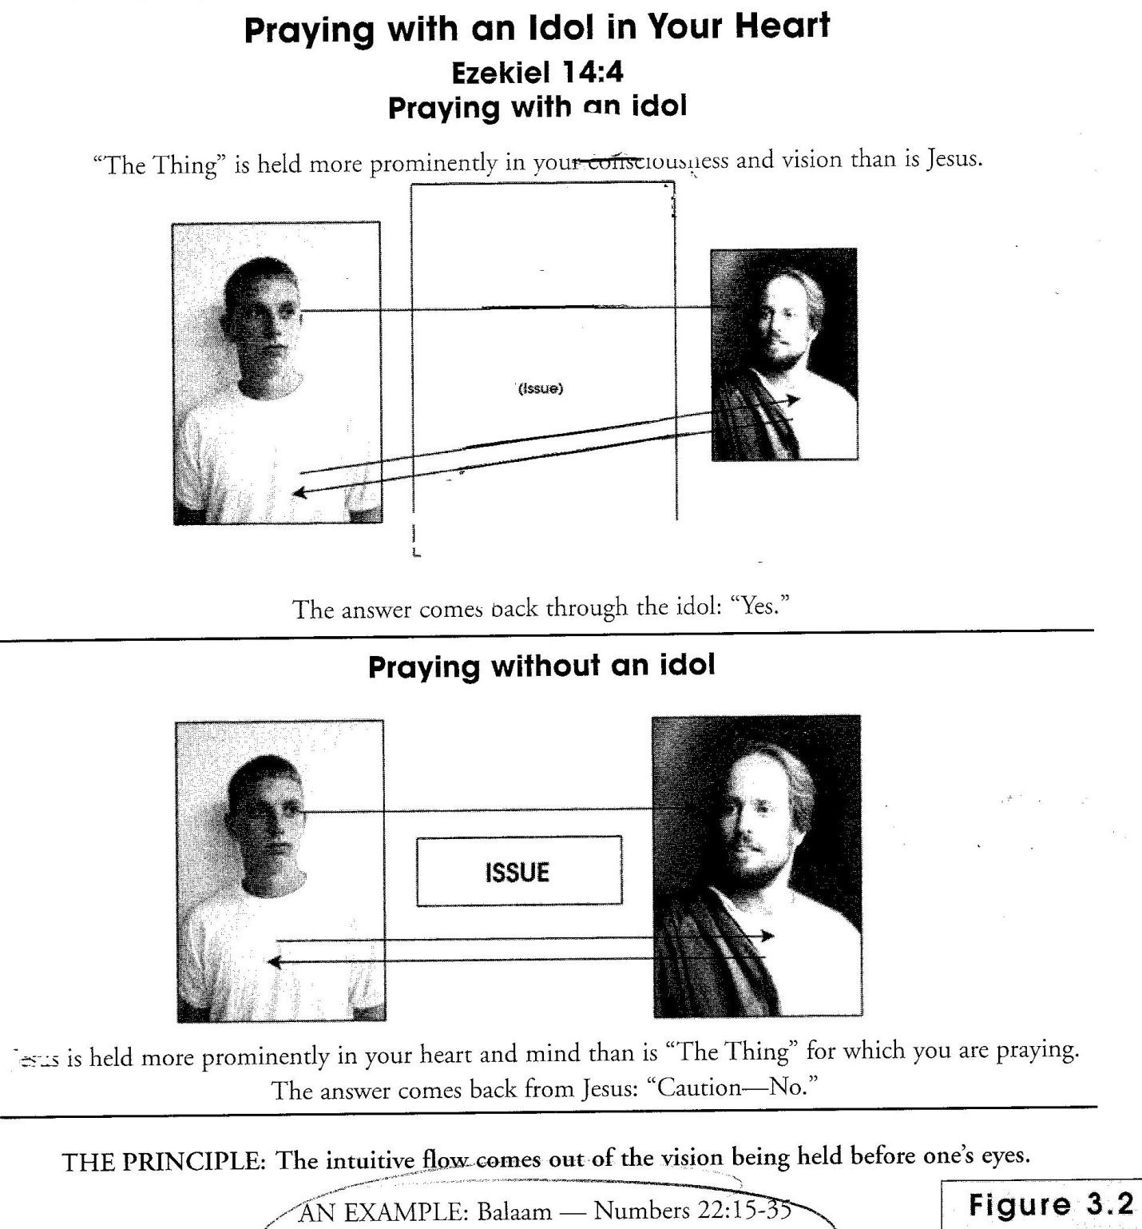

ISSUE or IDOL
When I come to the Lord in prayer and conversation, I am to come to Him as a living sacrifice, and I must lay down my will and be totally sold out to God’s will and direction concerning the issue about which I am praying. If I pray about the issue with my own “preconceived direction” in my heart based on an idol, my own _________ will interfere with God’s voice and direction. I may deceive myself when I think that I heard God’s voice when I was really hearing my own thoughts and acting on my own will because I was praying with an idol.
James 4:1-3 exhorts us regarding our own desires and their effect on our lives by stating “What causes fights and quarrels among you? Don’t they come from your __________ that battle within you (i.e. boil up)? You want something and you do not get it. You kill and covet, but you cannot have what you want. You quarrel and fight. You do not have because you do not ask God. When you ask, you do not receive, because you ask with the wrong motives, that you may spend what you get on your own pleasures.”
Instead, the Bible does give us a reliable pattern for approaching God and the right attitude to have when presenting our needs and concerns to Him. Psalm 37:4 states “Delight yourself in the Lord and he will give you the ______ of your heart”.
Do you see that praying with an idol in your heart skews the pure flow from God to you and often misguides you to wrong choices and conclusions?
The Principle of Pure Focus is this: “The intuitive flow comes out of the vision I am holding before my eyes. That is why I am commanded to fix my eyes on Jesus, the author and perfecter of my faith. Only that pure focus makes the vision pure.
When we pray with an idol in our hearts, we may get an affirmative answer from the Lord, but it will bring destruction in its many forms. Therefore, when we pray, we must be certain that our vision is purified and that we see Jesus as the One who is MUCH LARGER than the object or issue for which we are praying. Only then will our answer be pure and life-giving.

In conclusion, we are truly transformed by the renewing of our mind when we have gazed upon Him (Heb.12:2) with loving affection for so long that we become the reflection of His glory (2Cor. 3:18), taking on His character (Gal. 5:22,23) and His power (dunamis and exousia). A union has taken place in our spirits (1 Cor. 6:17), and we understand and live out “I have been crucified with Christ and I no longer live, but Christ lives in me…” Gal. 2:20.

- KEY # 3 Look for vision as you pray
HOW I AM TO USE THE EYES OF MY HEART
Our ability to see in the spirit is a primary sense by which we perceive the spiritual dimension. In light of our relationship with God being a heart–to–heart and Spirit-to-spirit reality, we should expect this faculty to be central in our relationship with God. We tend to live more in the world of logical concepts and rational thinking than in the world of heart impressions, dreams and visions. It is God that opens these doors to us as we “abide in Him”. God wants to communicate to us through the eyes of our hearts, giving us dreams, visions and godly imagination, but first we must recognize this sense within us and the importance it can have as we present it to be used by Him. For approximately 25 years of my walk with Christ, I did not see many visions or dreams. That all changed when God woke me up in 2004/2005. When He gave me two dreams that inspired me to look with the eyes of my heart more intently to Him! Below are several scriptures given to us to inspire the right side of our brains to see God through dreams and visions:
Acts 2:17 states “In the last days, God says, I will pour out my Spirit on all people. Your sons and daughters will___________ and your young men shall see ___________ and your old men will dream ______________”.
Hab. 2:1-3 reveals several issues that involve Habakkuk’s use of his “eyes of the heart”. Let’s read this passage together and see what Habakkuk’s preparation looked like in anticipation of hearing from God.
“I will stand at my watch and station myself on the ramparts; I will ________ _________what He will say to me, and what answer I am to give to this complaint.”
Then the Lord replied:
“Write down the revelation and make it plain on tablets so that a herald may run with it. For the revelation awaits an appointed time, it speaks of the end and will not prove false. Though it linger, ________ for it, it will certainly come and will not delay”.
What was Habakkuk’s stance before the Lord? __________________________.
What were Habakkuk’s expectations before the Lord? _____________________ ________________________________________________________________
What two things did the Lord ask Habakkuk to do?
1.________________________ Why?________________________________
2.________________________ Why?________________________________
Revelation 4:1-2 shows us what happened to John as he looked inwardly for a __________ and heard a voice…..”After this I _____________, and there before me was a door standing open in heaven. And the voice I had first heard speaking to me like a trumpet said, “Come up here, and I will show you what must take place after this.” At once I was in the spirit and there before me was a throne in heaven with someone sitting on it.”
What was John’s stance before seeing the door open in heaven? _____________
__________________________________________________________________
John 5:19-20 states “Jesus gave them this answer: “I tell you the truth, the Son can do nothing by himself; he can do only what he ________ His Father doing, because whatever the Father does the Son also does. For the Father loves the Son and shows Him all he does…”
What is Jesus’ stance before the Father? ________________________________
What is Jesus intent with respect to what He sees the Father doing?___________
___________________________________________________________________
What does the Father “show” the Son? __________________________________
__________________________________________________________________
Therefore, the “eyes of our hearts” (Eph 1:17-18) is a spiritual sense of our hearts. It is one of the ways man’s heart communicates. One’s ability to think in terms of images and pictures is extremely important to the Christian’s life. Spiritual maturity involves both knowing how to present our logical faculties and our visionary faculties to the Holy Spirit for His use. The results are Spirit-led reasoning and godly imagination, visions and dreams.
Upon a close examination of the scriptures, we see that dreams and visions have been prevalent throughout the history of God’s relationship with men and women.
Defining Visions:
- Spontaneous Vision on the Screen within your mind
At any particular time, we may receive a spontaneous inner picture in the same manner as we receive spontaneous rhema. God may give you a vision of the face of a loved one or friend and you just know that you are to pray for that person right then. The picture or image that bubbles up may be light and gentle and is seen within. It may be sharp or hazy, precise or unclear. Almost everyone polled in the book “How to hear God’s Voice” has experienced this type of vision.
- Spontaneous Vision while in Prayer
Similar to the spontaneous visions that may come to us anytime, thoughts, pictures and concepts also come upon us when we are in prayer. They sometimes bring conviction. Sometimes we find ourselves trying to turn off the thoughts and pictures of God, although we know they are true when they come upon us. Spontaneous visions while in prayer inspire us to drawn ourselves closer to God and love him more.
- Seeing a Vision outside Yourself
On this level, a person actually sees a vision outside himself, with the eyes of his heart. For example, Elisha prayed and said, “Oh Lord, I pray, open his eyes that he may see.’ And the Lord opened the servant’s eyes, and he saw; and behold, the mountain was full of horses and chariots of fire all around Elisha” (2 Kings 6:17). According to the author of “How to hear God’s voice”, only about 15% of Christians he polled have experienced this type of vision.

- Vision while in a Trance
A vision can be seen while in a trance. Peter had this experience in Acts 10:10-23. Trance-like visions are not common in Scriptures or church settings and approximately 5% of Christian’s claimed to have had this experience.
- The Visionary Encounter of Dreams
Paul received a vision in the night while he was asleep (Act 16:9-10). Spiritual dreams are common in Scripture (about 50 in the Bible) and they are also common among God’s people today. About 85% of Christians polled in the book stated that they have had dreams that they knew came from God.
Visions on each of these five levels are equally valid and scriptural, and all are to be thoroughly tested, weighed and considered.
How do you most often experience God’s thoughts and pictures in the form of visions?
_______________________________________________________________
When are you most likely to receive a vision from the Lord?
_______________________________________________________________
First steps in beginning to see visions
As I have mentioned to you earlier this morning, God began to wake me up to relating to Him through the right side of my brain approximately 24 years after being saved, by two distinct dreams that made an incredible imprint on my soul.
The dreams themselves drew me to start looking for God more through pictures and concepts than at any time previously in my walk with Him. I had spent many years memorizing scripture and could recall hundreds of scriptures from memory but God wanted me to experience Him from both sides of my brain. As I continued to look for Christ not just in a scripture passage but actually in the form of a person that walked on this earth, my mind began to open up to images, pictures and even stories given to me by the Holy Spirit.
What I realized was that God wanted to train me to see His thoughts and pictures from a spontaneous theater in my mind and heart.
- The first step that God brought me through was to show me that I can believe in the value of living in the world of dreams and visions. God did not take away or discount giving me scripture as a form of communication but God was in the process of lighting the right side of my brain with pictures and images. This was something new that God allowed me to experience in my walk with Him.
You and I must see the language of the heart as a primary means that God uses to communicate with us. Jesus often spoke in parables and for those who were ready to hear all His words, their hearts were pierced with understanding as the eyes and ears of their hearts received the truth.
- After originally experiencing the two dreams that began to wake me up, I began to understand that God does speak to me and you in this way, not just in the form of scripture. I then asked God to increase my capacity to see Him in the form of dreams and visions, and He did show me more to the extent that I could receive them in faith!
God really challenged me to start pursuing him through spontaneous flow in dreams and visions and through the last several years, I have grown in my relationship with God through these types of dreams and visions.
- I noticed that when I began to pray, God did give me pictures and visions of what I was praying about along with words from the Holy Spirit. When we look at life, we see that we are more deeply affected by pictures than by simple cognitive communication. For example, we prefer television over radio, a speaker who tells vivid stories over a didactic lecturer, a testimony over a book of theology. Pictures enhance our worldview more than any concept or merely verbal idea.
God gave me a compelling reason to search for Him in every way I could find Him. He called me to help lead my congregation through a very hard season of church life. God called me to become an elder and then to oversee the transition of our founding pastor and then to oversee the re-financing of our real estate debt. That time was intense for me, my family and our church. When God called me and I said that I would follow him through the season, God gave me spiritual gifting so that I could see what he was doing to and through our church, HE GAVE ME AN EXTRA MEASURE OF FAITH for the season ahead and I most certainly needed to hear every word from the Lord to get through the season of transition!
Has God stretched and strengthened you to hear and see him with your whole heart in the form of dreams and vision for a new work he has prepared for you?
__________________________________________________________________
Take time to ask God to show you more of his thoughts, visions and dreams for your life and ministry ahead of you and journal them below.
______________________________________________________________________________________________________________________________________________________________________________________________________
If you are struggling to grasp the information and concepts presented above, take time to go through “Allowing God to Restore Your Visionary Capacity” located in the Resource Guide and ask God to show you what the barriers are to restoring your capacity to see and hear him in the forms of dreams and visions. Be ready to discuss this with your POD group later this month.
- KEY # 4 WRITING DOWN THE FLOW OF THOUGHTS AND PICTURES THAT COME TO YOU
Recording your conversations with God is a great method to help you ______ in your ________. Two-way journaling is a biblical method that can help you grow in the discernment of the voice of God in your heart. This form of journaling is basically recording your prayers and what you sense to be God’s answer. If we can learn to clearly discern His voice speaking within us, we will be much more confident in our walk with the Holy Spirit. Journaling is a way to sort out God’s thoughts and pictures.

Key Benefit of Journaling
One of the greatest benefits of using journaling during your communion with the Lord is that it allows you to receive freely the spontaneous flow of ideas that come to your mind, in faith believing that they are from God, without short-circuiting them by subjecting them to rational and sensory doubt while you are receiving them. Journaling allows you to write in faith believing the flow of thoughts and pictures are from the Lord, knowing that you will be able to test those thoughts that you have journaled down later.
Please refer to the article “Writing Down the Flow of Thoughts and Pictures that come to you” found in the attached Resource Guide for a more detailed document on journaling as a discipline in our walks with God.
See in the Resource Guide “The Most Common Reasons for Mistakes in Journaling” information sheet and work through the issues presented in the document. Also take the “Journal Exercise” sheet and practice journaling for one session. Share with your group the outcome of your exercise.

Take a minute to write down your thoughts, concerns and questions about what you have learned today.______________________________________________
______________________________________________________________________________________________________________________________________
Ask the Lord what He is challenging you to do with what you have learned today. Go back and review your notes. Summarize them below. ___________________
____________________________________________________________________________________________________________________________________

OUR KEYS TO THE KINGDOM
The main purpose for learning to hear God’s voice is so that you might really know Him and His will for your life and know His desires, His hurts, and His character and nature! Please read John 17:3.

FIVE KEY ASPECTS OF PRAYERS THAT POSTION YOU TO HEAR FROM GOD:
- Mark 12:30, Make Me your greatest treasure so I can give Myself to you.
- Jer. 29.13, Search for Me with your whole heart so I can reveal Myself to you.
- Prov. 3:5, Trust Me with your whole heart so I can guide your steps.
- Psalm 9:1, Praise Me with you whole heart so I can gift you with My presence.
- Joel 2:12, Return to Me with your whole heart so that I can be compassionate and bless you.

REMEMBER IN SUMMARY:
- Key #1 Learn to recognize God’s voice as spontaneous thoughts that light on your mind.
- Key #2 Quite yourself
- Key #3 Look for a vision as you pray.
- Key #4 Write down your flow of thoughts and pictures.

APPLICATION NEXT STEPS: As you review this session in your own personal quiet time, with your POD mates and others, ask yourself; What is God saying to me? and How am I going to respond? Begin now to look for opportunities to start sharing what you have learned with others. That is disciple making. Take advantage of the transformative power of prayer, journaling, writing out personal application/next steps, and memorizing key scriptures. Also, be sure to read the articles and one or more of the books mentioned in the resource guide at the end of each of the seven sessions.

KEY TAKE-AWAYS AND MY PERSONAL APPLICATION/NEXT STEPS: __________________________________________________________________________________________________________________________________________________________________________________________________________________________________________________________________________________________________________________________________________________________________________________________________________________________________________________________________________________________________________________________________________________________________Scripture I will commit to memorize from this session:

